CSA1708-ARTIFICIAL INTELLIGENCE
LAB EXPERIMENTS
Program 24 : Prolog Program for Diet Suggestion Based on Disease
Aim
To use Prolog to retrieve sample diet options by disease.
Algorithm
1. Store diseases and example diet options as facts.
2. Define a rule to match a disease with its options.
3. Query the rule with a selected disease.
4. Use backtracking to display additional matching options.
Program
diet(diabetes, 'low-sugar meals').
diet(diabetes, 'whole grains and vegetables').
diet(hypertension, 'low-salt meals').
diet(hypertension, 'fruits and vegetables').
diet(anemia, 'iron-rich foods').
suggest(Disease, Food) :-
diet(Disease, Food).
Sample Input
?- suggest(diabetes, Food).
?- suggest(anemia, Food).
Program Execution
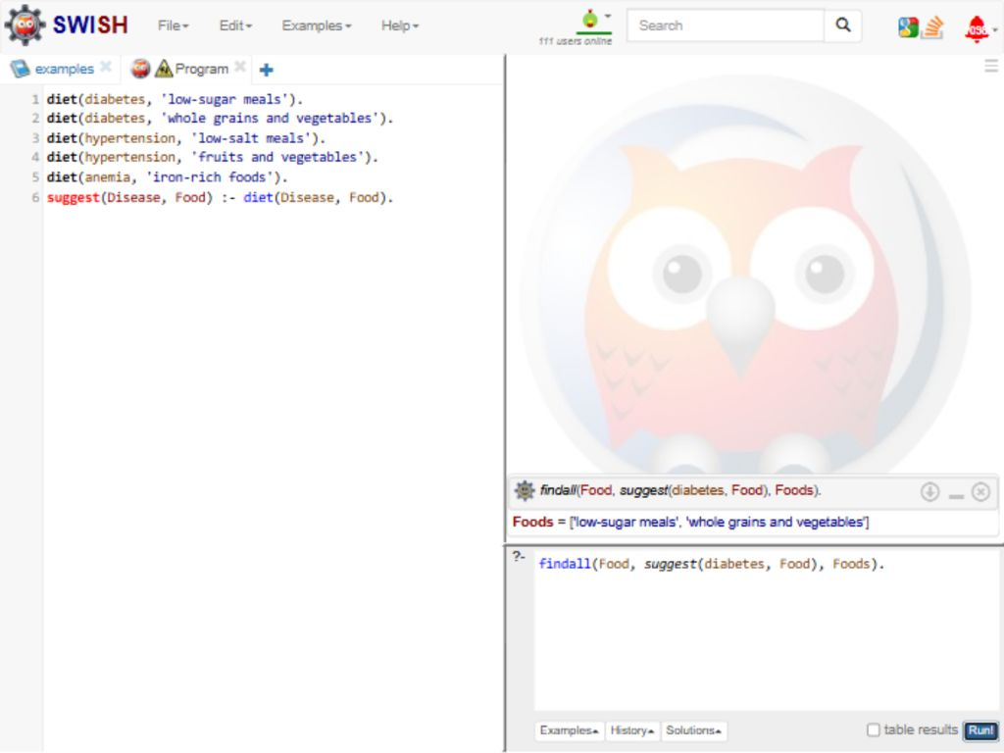
RESULT
Thus, the selected diseases returned their stored diet options.

